Prosthetic Hand Research Main Page
Prosthetic Hand Research Main Page

Main page for research, create a tab of your own with your name under your respective team and just dump info + research with references/links.
Your page should have enough info so that someone else could see what you have found, go into the provided link/find the reference material and view the info themselves.

Left HandTeam/Mechanism
Anything relevant to the Left Hand Team/ Left Hand Unique mechanism can go here, or in your sub pages.

Test Page

Etienne
Prosthetics stronger human hand, but not more dexterous
Tactile sensor - connect to corresponding nerve

-Left or right hand prioritise discussion:

-Ensure remove by himself?

Combination approach

-SLA printer on campus - better than FDM?
No SLA is more brittle, more about details

-Filament research —> USE TPU
TPU | PLA
Flexible, comfortable, resistant bending/tearing | Brittle, softens with body heat, uncomfortable
Petg also good

Cheap purely mechanical body driven
Brachydactyly
Syndactyly
Rolling contact joints https://www.youtube.com/watch?v=TQiLLcumqDw
https://hackaday.com/2024/05/17/emulating-biology-for-robots-with-rolling-contact-joints/
Key decisions
Design for cost effective and quick 3D printing

Tolerance
0.1 - if too tight use a file and remove material
13mm → 13.5 mm

CAD
Scale
Diameter same
Table lengths of fingers - use his file
Extend the sides on the bigger one - flanges (extrude)
1.5 cm
5 to 10° outwards - see image
Bigger one symmetrical mirror
Diameter the same

Outer flange (no angle)
Outer symmetrical
Top view extrude + add chamfer

Inner phalange
Flatten bump phalange for grip X
Move channels - a little bit inwards X
Outer phalange:
Maybe increase diameter other holes
Deeper grooves - double
Bigger flanges - 60% bigger and also change shape as in photo X
//
More material on outside
Extend to inside for 13.5 mm clearance for 13mm thing inside + fillet

Split pin

Personal 3D notes
-infill
Dowels are recommended since you can re-try printing dowels pins quickly rather that reprinting entire parts
-solidworks convert to step
-slicer value has to equal nozzle diameter
Orient??
Which infill? - gyroid
Wall loops - more = thicker = more strength
Infill only 15%
All overhangs are 30° so no support material is required
Print critical holes with their axes vertical as opposed to horizontal, Vertical holes will be more concentric.
Bridging allows a 90° overhang to be produced over short lengths.
Slots are put in place to reduce the material & tim
Horizontal holes printed are often undersized and you will be required to compensate for this
Use rounded edges, so the extruder does not have to make a sharp turn when printing
Do not filet the bottom edges (face in contact with the bed) as this promotes warping. Chamfers are ideal as it prevents elephant's foot
It is a lot easier to design modular assemblies. Print parts separately and bolt them together, rather than having to reprint a large part all over again because one tolerance was wrong.
FDM parts are anisotropic and much more likely to fail across layer lines — compromise diagonal but hassle to print
Text: Add embossed or Debossed Text onto a model. It is useful to embed the version of parts
Printing curved surfaces (cylinders/Spheres) on the plate will result in a flat bottom on the part. You can split a sphere up – printing it on its flat face and then join them together after, but consider tolerances.
Raft
A dovetail is a special connector shape that slides together like a drawer joint.

What it looks like
Imagine a T‑shaped track or a trapezoid that locks in place when you slide the two halves together.
IPA liquid to remove supports (iso propyl alcohol

Bowden cable
Master capstan

Mervyn's Notes
Preliminary Research - Finger Prosthetic (Bassie)
Most of the focus will be on the left hand - images are provided below of what it looks like:
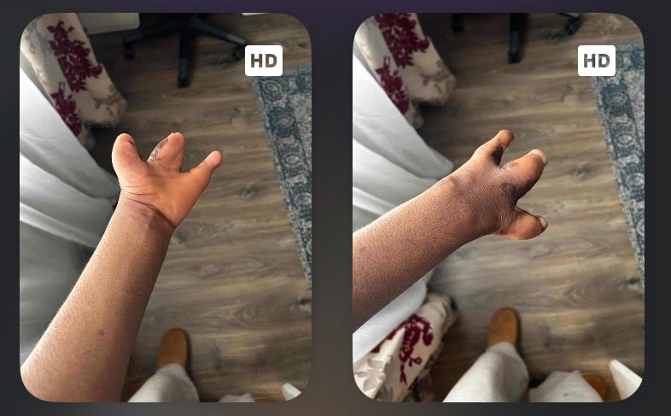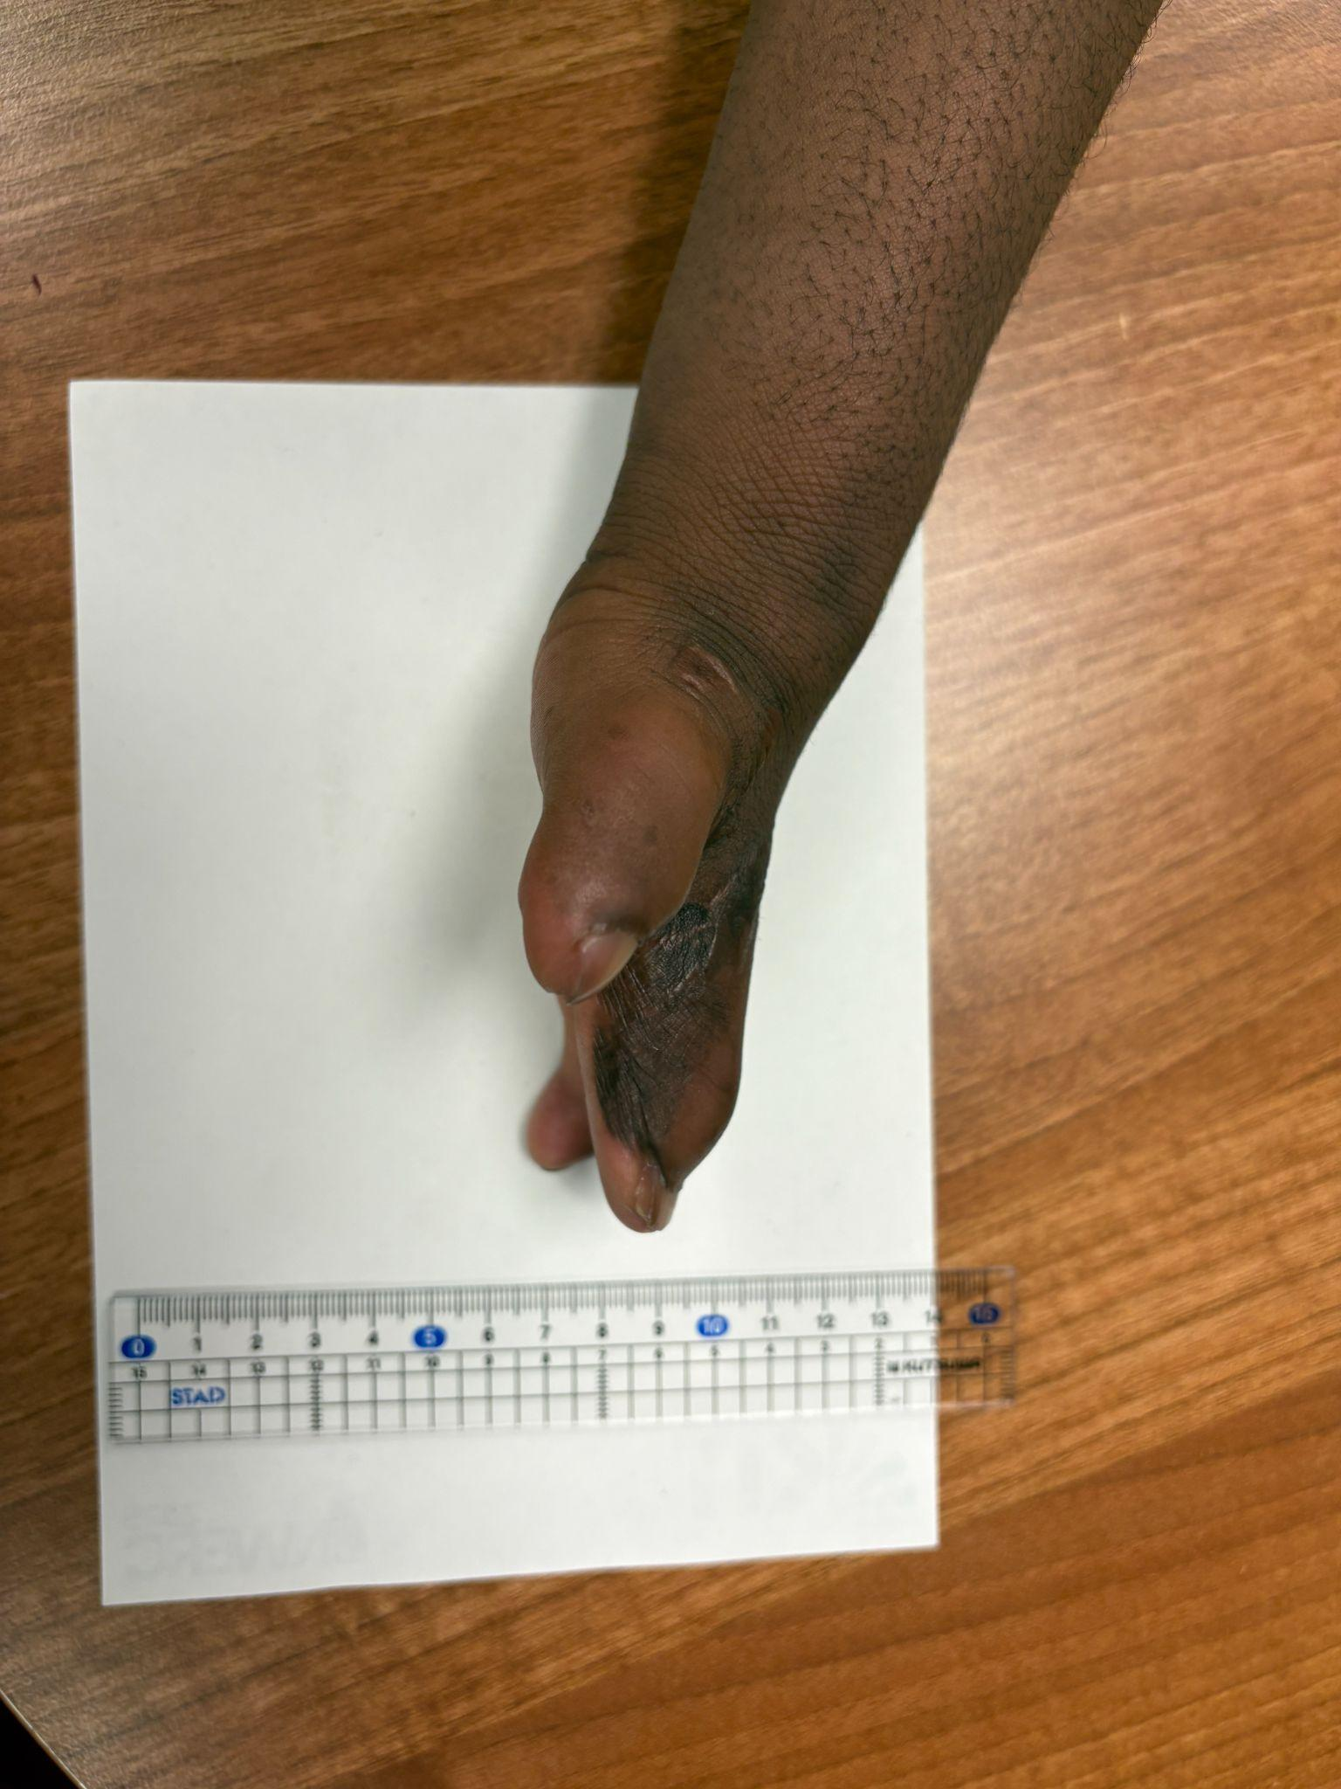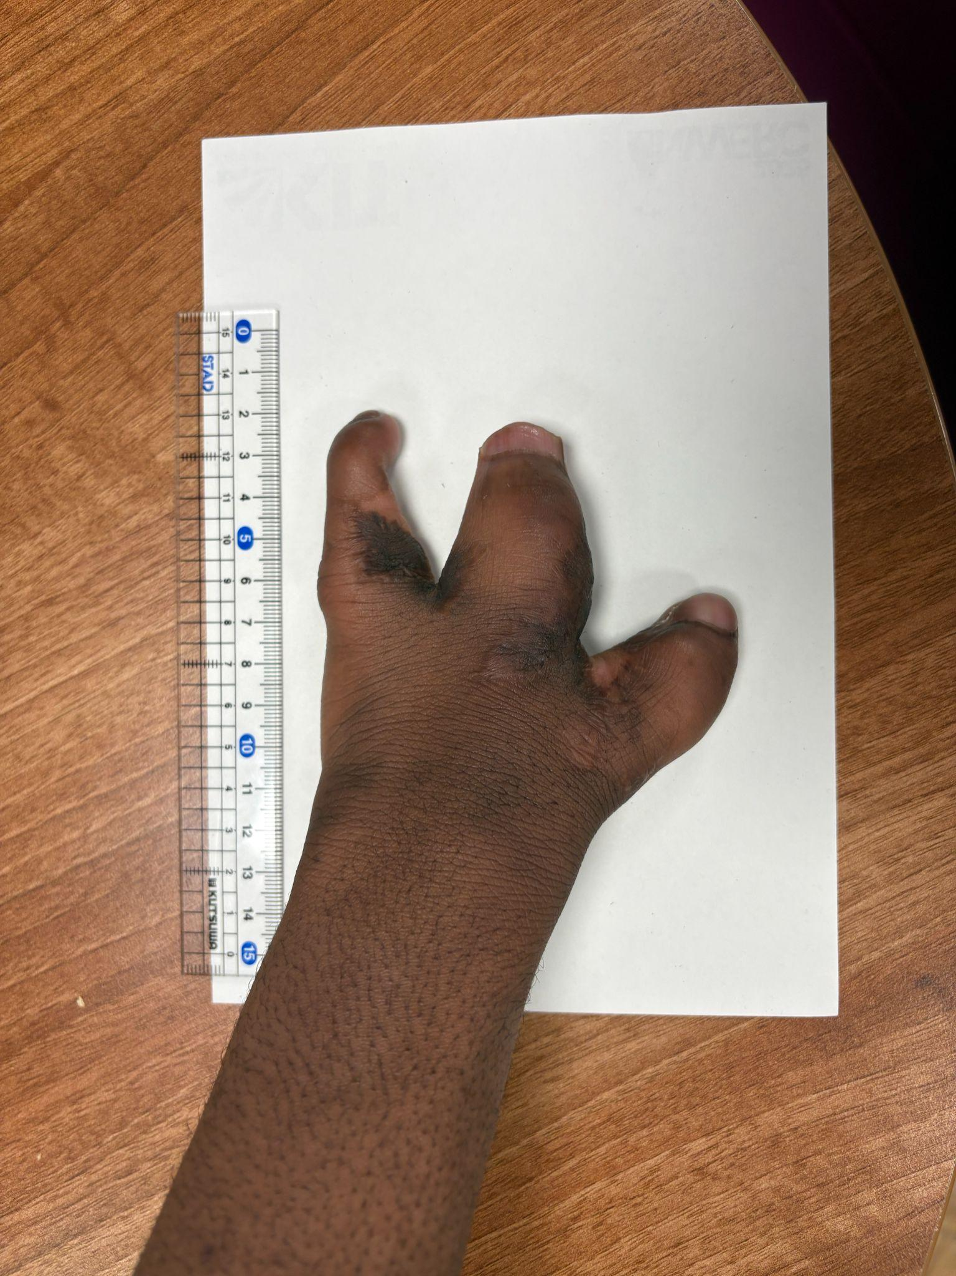
Task at hand (until 15th June): Carry out preliminary research on how human hands usually grip objects, and alternatives to the Osser/ Pinky Example. Any research is good.
- Start thinking about potential ideas of the prototype.
Client preferences: Easy to remove/detach, prefers hand-mounted > digit-mounted prosthesis.
- Ability of left hand: Can move left (thumb) and right (pinky) digits like normal, middle digit cannot be controlled.

Useful Websites:
- https://www.ossur/com/en-gb/prosthetics/products/arms/partial-hand#mechanical
- https://www.centricmotion.com.au/learn/blog-post-multigrip-prostheses
- https://surgeryreference.aofoundation.org/orthopedic-trauma/adult-trauma/further-reading/hand-functional-anatomy-and-biomechanical-concepts#the-weight-bearing-hand
- MCPDriver® | Body-driven Finger Prosthesis | Össur

Human research:
- Bassie likely a case of macrodactyly -> abnormal hand shape and growth. Left hand is more of a severe case to his right.
- Types of main grip types: Power, Hook and Pinch (see below in order - from CentricMotion)
  - Power (left) - Wrap around and hold wholly around a cylindrical object.
  - Hook (middle) - index->pinky tightly wrapped around ‘hook’
  - Pinch - thumb + index to hold onto tiny/thin objects (e.g. coin)
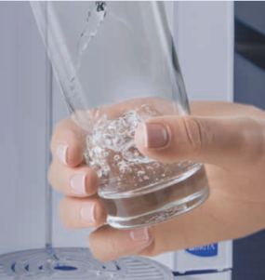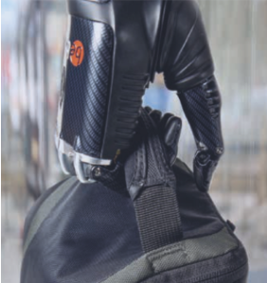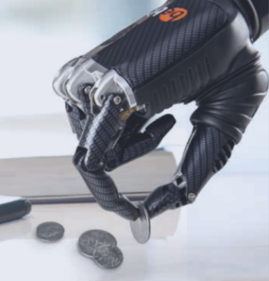
Note: Tripod / Lateral grip also mentioned in website - excluded for this project as this doesn’t align to Bassie’s needs (he will just remove the prosthesis for these grip motions)

Prosthetic Research:
- Ossur website - consider Thumbdriver (metal-based mechanism) and PIPdriver (purely plastic) designs.
  - For Bassie - mechanically-driven mechanism to do a pair-wise motion linking pinky to middle digit in conjunction with each other. (i.e. if the pinky moves, so will the middle).
- Facile hand attachment - use strap/velcro.
- For digit tips - use TPU or conductive fibre?
  - Conductive fibre IF Bassie would like to use it for touchscreen purposes.

Design Ideas:
- Strap design - slide-in coil + belt-like strap to tighten?
  - If coil = plastic, consider adding rubber or thin, non-irritant padding on the inside for comfort.
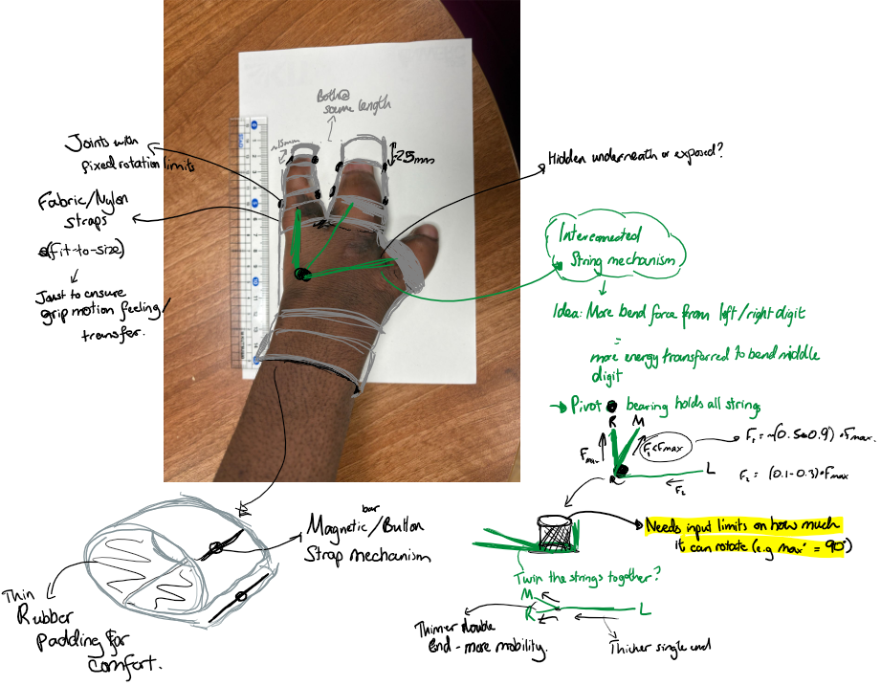
- String configuration
- How the strings will be attached to the rest of the hand
Basically mechanistic
- Wrist design not 3D printed ideally, use strap (magnetic-slap wrist/ fabric-based)
  - Could be slotted

Right Hand Team/Digit Mechanism
Anything relevant to the Right Hand Team/ Right Hand Unique mechanism can go here, or in your sub pages.

Alex
Inspo - Ian Davis
https://www.youtube.com/@missingpartsclub

Long history and experience of building prosthetic hands for personal use
Purely mechanical

https://www.youtube.com/watch?v=RdDqXClKzNo
3D Printed fingers that achieve “250 degrees of motion” for “half an inch of input distance”.
Printed in ABS, also has adjustable sliding fingertips for grip.

https://www.youtube.com/watch?v=fAJ11GPfk9c
In his experience, 3D printing plastic not durable enough for daily use, which makes sense. This is a prototype. For more durability, use PETG filament but still similar results in failure.

Resin: failure - cracking due to UV exposure.
Developing hairline cracks.

Any load applied would cause the fingers to snap.

https://www.youtube.com/watch?v=BneYK1pgXmg
Load applied to fingers causes them to lock, otherwise they are free to swing open and closed.

https://www.youtube.com/watch?v=K-oMvhZazBI
TPU socket, located by buttons on the socket to divots in the device. Attachment is somewhat stiff, having to squish the hand and socket into the metal frame. Socket will loosen with time. May be a bit of a hassle initially putting it on.

Overall his mechanism is 100% analog, use of chain belts and linkages.

Info - Human Joints and their Artificial Replacements, Peter S. Walker (1977),
Ch 1. Positions and Movements - movements of joints - pg. 50 Movement of the Elbow, the MCP, and Other Joints

Ch 2 pg. 99 Internal Forces in Normal Hands

Wrist Strap Ideas
This document will contain wrist strap/holder ideas to support the mechanisms proposed throughout the project. The purpose of the wrist design is to ensure that Bassie can wear it as ease without the device getting loose and is well attached to his hand.
Mechanism | Pros | Cons
Side-release buckle | Highly secure than most  Can be 3D printed with certain materials (PETG, not PLA) | Small tolerance factor; needs to match almost exactly to Bassie’s wrist  Needs a semi-flexible material against cyclic compression (consider the user needs to press)  Will demand some technical expertise and calculations.
Magnetic | Quick,rapid attachment; small amount of magnet required to work.  Minimal user effort to adjust  Feasible integration with wrist design  Relatively cheap | Lack of adjustability unless the buckle around can move?  Hard to find/shape magnet into design
Snap Fastener | Simple, easy mechanism for security around wrist | Not adjustable, otherwise a bunch of female ‘snaps’ need to be soldered into wrist design  Not sure how to bolt the parts/ integrate with 3D print?
Hook and Loop (velcro) | Adjustable, versatile and widely used  Common materials: Velcro/Nylon (see link)  Cheap to use | Will need to buy from external source  Materials need to be as comfortable to the user as much as possible.  Requires buckle loops to work; can be done by adjusting CAD design at wrist end
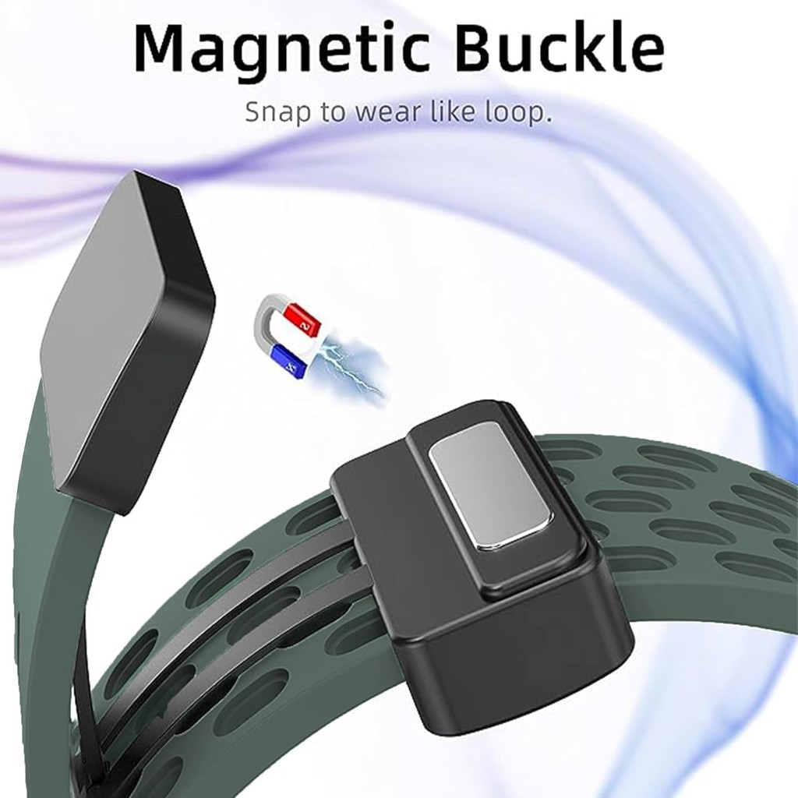
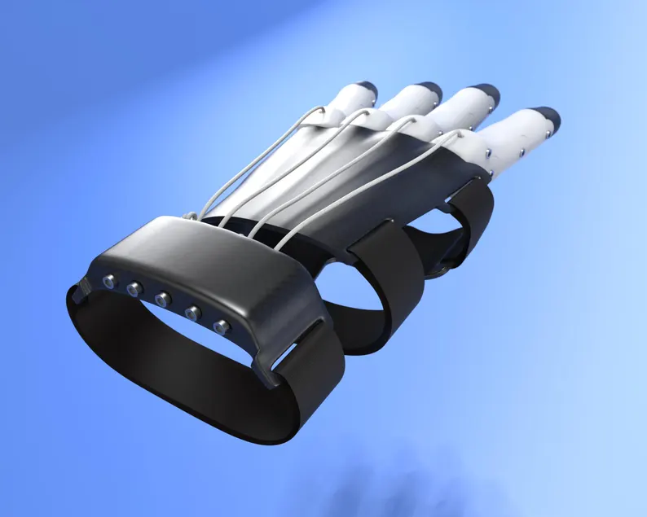
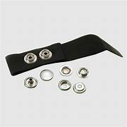
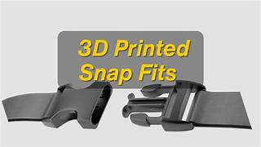
Useful websites:
https://www.unionfab.com/blog/2025/06/3d-print-snap-fit - for Snap-fastener mechanism. But generally useful for 3D printing wrist mechanisms as a whole
https://www.amazon.co.uk/dp/B0F6CJKMYT/?_encoding=UTF8&aref=AH9tp9kX7M&pd_rd_i=B0F6CJKMYT&ref_=sbx_be_s_sparkle_ssd_img&qid=1782123907&pd_rd_w=VDNQG&content-id=amzn1.sym.358d43ed-81c4-455e-87e8-a84d0543fd5e%3Aamzn1.sym.358d43ed-81c4-455e-87e8-a84d0543fd5e&pf_rd_p=358d43ed-81c4-455e-87e8-a84d0543fd5e&pf_rd_r=J3XVXEHR8WWR94HTYTXV&pd_rd_wg=kLxHe&pd_rd_r=5b2f3069-9f0b-4d10-aa77-1561ff31a000&pd_rd_plhdr=t
- For hook and loop mechanism -> model product to buy (~£9.99)

